Summary

This report introduces the “data logging application”, abbreviated with (DLA). DLA is part of the data logging package that contains 2 independent applications:

1. Data Logging Application (DLA)
2. Logged Data Viewer (LDV)

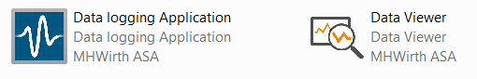

This report is dedicated to DLA.

Table of Contents

1 Objective 1

2 Introduction of functionalities 2

2.1 Main Functionality 2

2.1.1 Capture information in a file 2

2.1.2 TDMS File Structure 2

2.1.3 Exchangeability of TDMS file format 3

2.2 User Interface 4

2.2.1 Status Pane 4

2.2.2 Settings Pane 5

3 Revision History 6

# Objective

The objective is to record data online, as they are generated by various parts of the test setup.

Main features to achieve:

1. Stand-alone application that can be run on an independent PC
2. Record in a file that
   1. is readable in other applications such as Excel and MATLAB in addition to LabVIEW
   2. does not grow unexpectedly
3. Record data with time stamp and with given sampling rate
4. Record all available data on DDS regardless of the source

# Introduction of functionalities

## Main Functionality – Main Features

### Capture information in a file

This application saves data in a TDMS[1] file format, which is part of the NI technical data management solution. The NI technical data management solution includes three components:

* The NI TDMS file format for saving well-documented measurement data
* The NI DataFinder for quickly locating previously stored data sets
* NI DIAdem or the LabVIEW DataFinder Toolkit for processing data and creating reports

Table 1 shows the pros and cons of some of the most commonly chosen storage options for measurement data. More detailed comparison for data types is given [here](http://www.ni.com/white-paper/9630/en/).

Table 1 The TDMS file format combines the benefits of several data storage options in one file format

(Source ni.com – [click here](http://www.ni.com/white-paper/3727/en/))

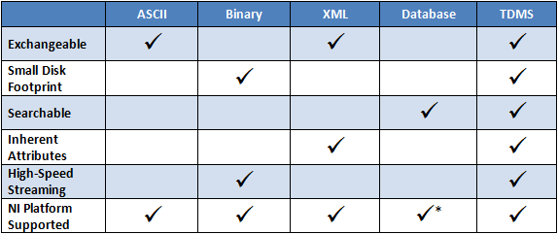

### TDMS File Structure

The binary TDMS file format is an easily exchangeable, inherently structured, high-speed-streaming-capable file format that, when combined with the other technologies in the NI TDM solution, becomes quickly searchable without the need for complicated and expensive database design, architecture, or maintenance.

The single, most important feature to understand about the internal format of the TDMS file structure is its inherent hierarchical organization. The TDMS file format is structured using three levels of hierarchy, as shown in Figure 1 << file, group, and channel >>.

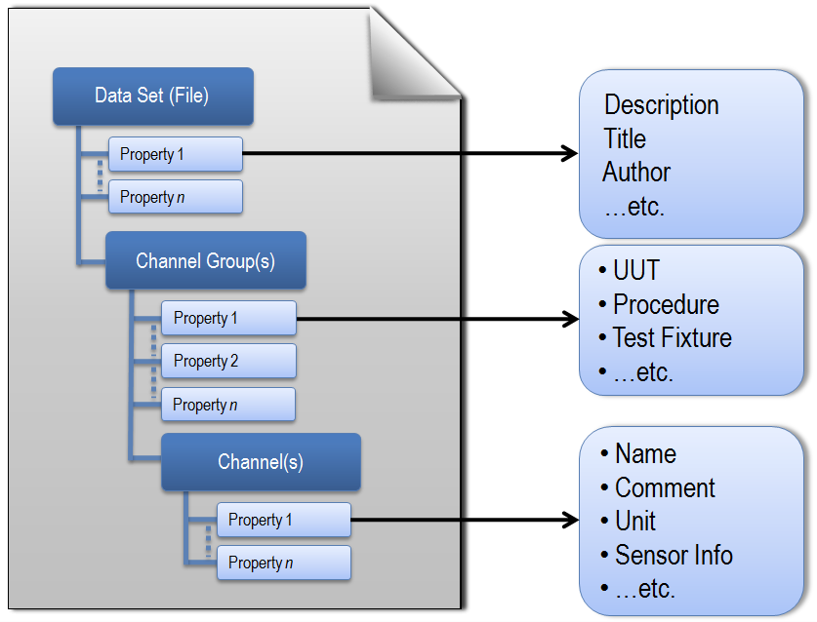

The file level can contain an unlimited number of groups, and each group can contain an unlimited number of channels. You can think of excel workbooks. A data set (TDMS file) is like an Excel workbook. Each channel group is like one sheet. Channels are like columns in sheets while each column has several inherent properties that can be set.

TDMS files also automatically generate a complimentary *.tdms_index file. This file provides consolidated information on all the attributes and pointers in the bulk data file that drastically speeds up read access to the data on larger data sets. This index file is not required for storage or distribution and automatically regenerates.

This is important to note that TDMS file format is a well-documented, rich file format. One can store an unlimited number of custom-defined scalar *attributes* to achieve well-documented and search-ready data files. The descriptive information located in the file, a key benefit of this model, provides an easy way to document the data without having to design your own header structure. As your documentation requirements increase, you do not have to redesign your application; you simply extend the model to meet your specific needs[2].

### Exchangeability of TDMS file format

#### .NET languages using measurement studio

The NI Measurement Studio TDM Streaming .NET Class Library provides a fast and flexible way to interface directly with TDMS files using .NET languages. Access to the TDM Streaming .NET Class Library is restricted to the Professional and Enterprise editions of Measurement Studio.

#### TDM C DLL

NI offers the TDM C DLL as a free download. It contains the necessary functions for reading and writing TDMS files from any application development environment that is flexible enough to enable DLL communication.

#### OpenOffice.org Calc

With the free add-in for OpenOffice.org Calc, you can load and process TDMS files including descriptive information in OpenOffice.org Calc.

#### Microsoft Excel Office

Using the free TDM Excel Add-in for Microsoft Excel, you can load and work with TDM and TDMS files in Excel. TDMS file can be opened and processed using Excel. It also can be saved as Excel workbooks. See details [here](http://www.ni.com/tutorial/12561/en/).

#### The MathWorks, Inc. MATLAB® Software

National Instruments has developed an example demonstrating how to adapt the TDM C DLL with a customized header file to interface with TDMS files from within The MathWorks, Inc. MATLAB® software. To learn more and download the example, see [MATLAB TDM Example User Guide](http://www.ni.com/white-paper/7446/en/).

## User Interface

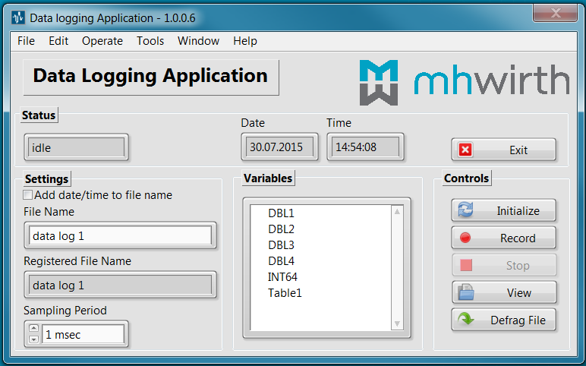

It has 4 main panes (sections).

1. Status
2. Settings
3. Variables
4. Controls

### Status Pane

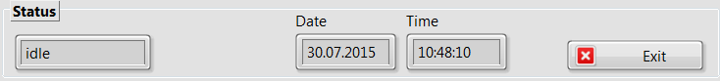

It shows the internal state of the application. It can be one the following:

* Initialize
* Idle
* Preparation
* Record
* Stop
* Exit
* Defrag
* View

*This is currently the internal state for debugging. As a stand-alone application, it should be changed to user-friendly status bar.*

The status pane also shows the system date and time.

It also has the “Exit” key, which will be disabled when the application is in Record and View states.

### Settings Pane

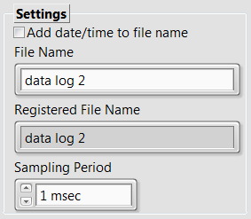

This is used to set the name of the file of the TDMS file and to set the sampling period in msec.

Checking “Add date/time to file name” and pressing “Initialize” key will result in the following name for the TDMS file. This can be used to avoid adding/overwriting to an existing file.

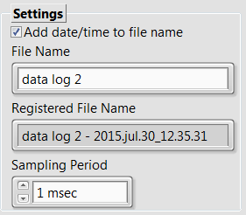 

If file exists, the data will be appended to the end of the file.

### Variables Pane

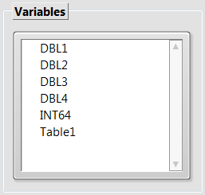

It lists all the available variables that can be stored. The user can select one or more.

Currently, the application makes one group for all scalars (double, int64, int32) and one group per 1-dimentional arrays (1D array of doubles).

### Controls Pane

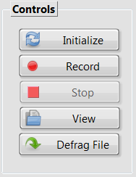

It contains 5 keys (except “Exit” which is located in the “Status” pane).

Depending on the application state, one/some of the keys might be disabled.

The main functionalities of the keys are described in the below table

|  |  |
| --- | --- |
| Key name | Main Functionality |
| Initialize | Get the File Name Base and make the file name and path ready for data logging |
| Record | Start recording data |
| Stop | Stop recording data |
| View | View the TDMS file after stopping |
| Defrag File | It defrags the TDMS file and removes scatters in the binary file |

### View State

If the TDMS file exists, will pop up the TDMS File Viewer, as shown below.

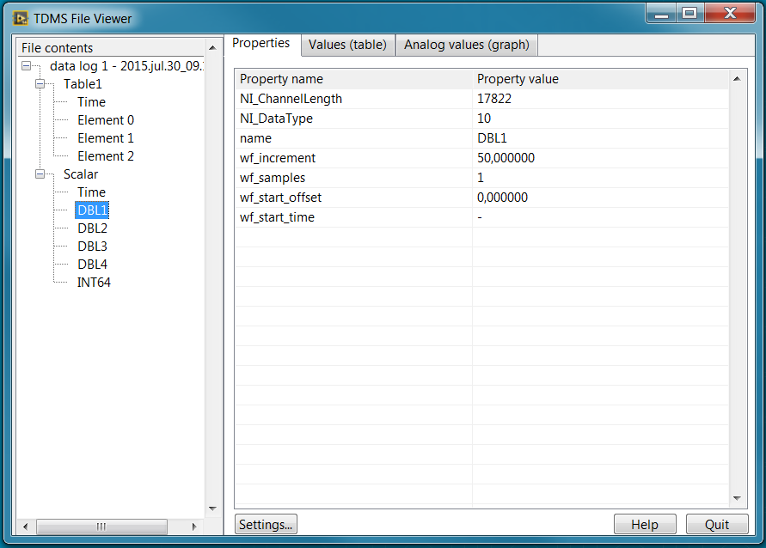

It provides basic access to the created file and logged data.

In the above picture, the properties of the variable DBL1 are shown. It is also possible to see and plot one or some variables.

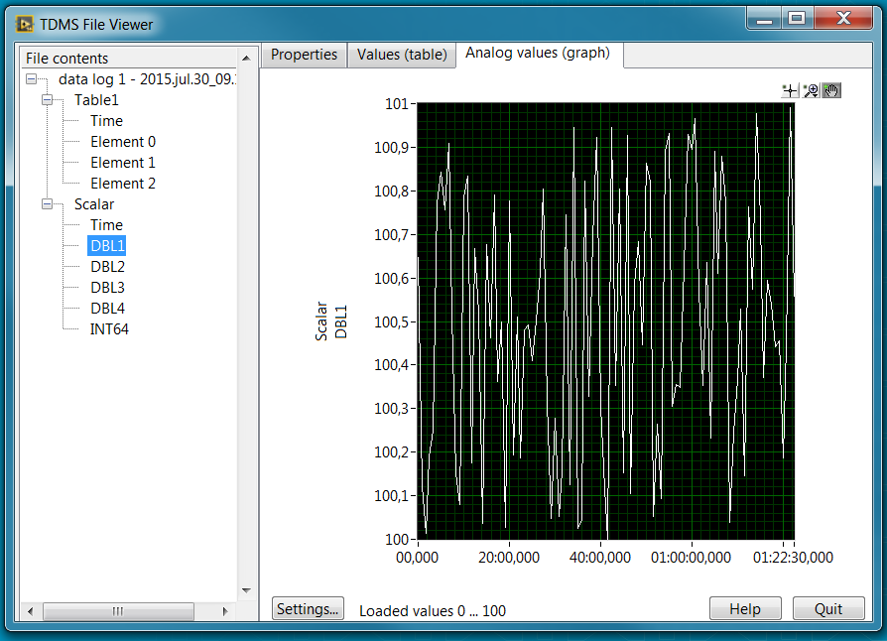

Figure 1 Plot of DBL1 from value 0 to 100. It is possible to modify the window.

The scalar variables are stored in the TDMS file in the following way.

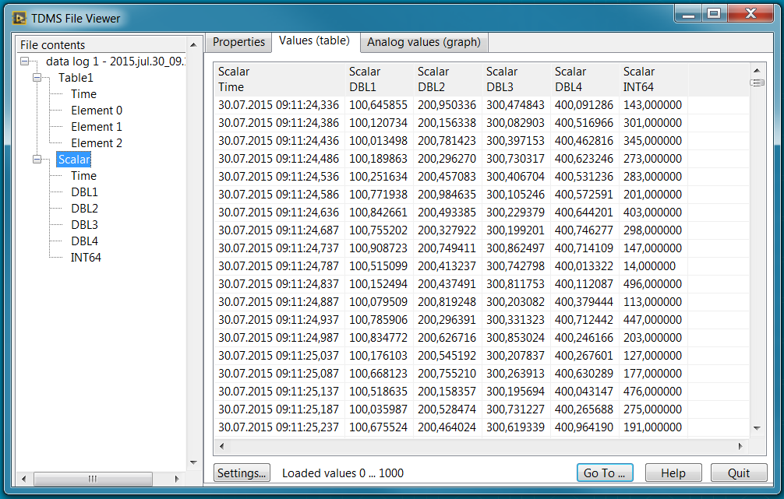

Figure 2 Scalar variables with time stamp

The picture below shows the way that 1D arrays are stored in the TDMS file.

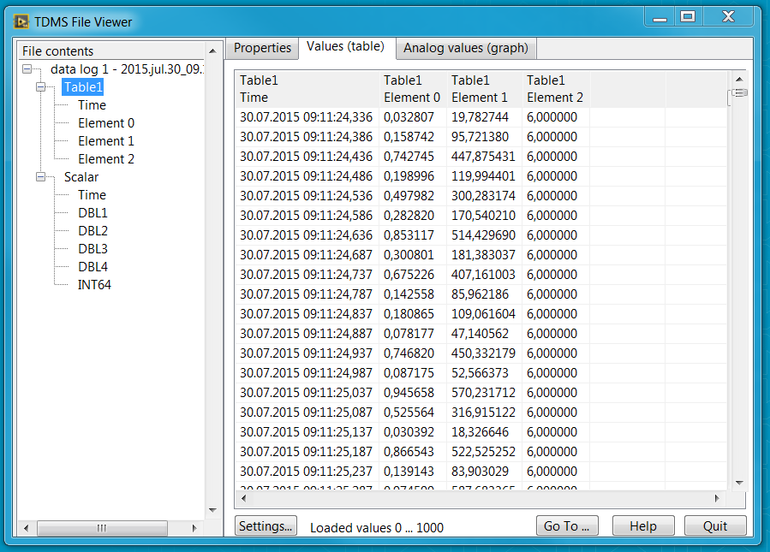

Figure 3 Storing 1D arrays with time stamps

### Defrag State and File Size

TDMS file might be scattered in long time of data logging. It results in larger file size. Defragment after stopping recording fixes scattered files and the file size will be as we expect from a binary file.

The file size is generally determined by the number of bytes and variables, as the TDMS file format is binary.

## File as opened in Microsoft Excel

Installing a free plug-in, you can open a TDMS file as Excel Workbook. Groups are sheets, and channels are columns in the sheets.

See below figures as how TDMS file opens in Microsoft Excel.

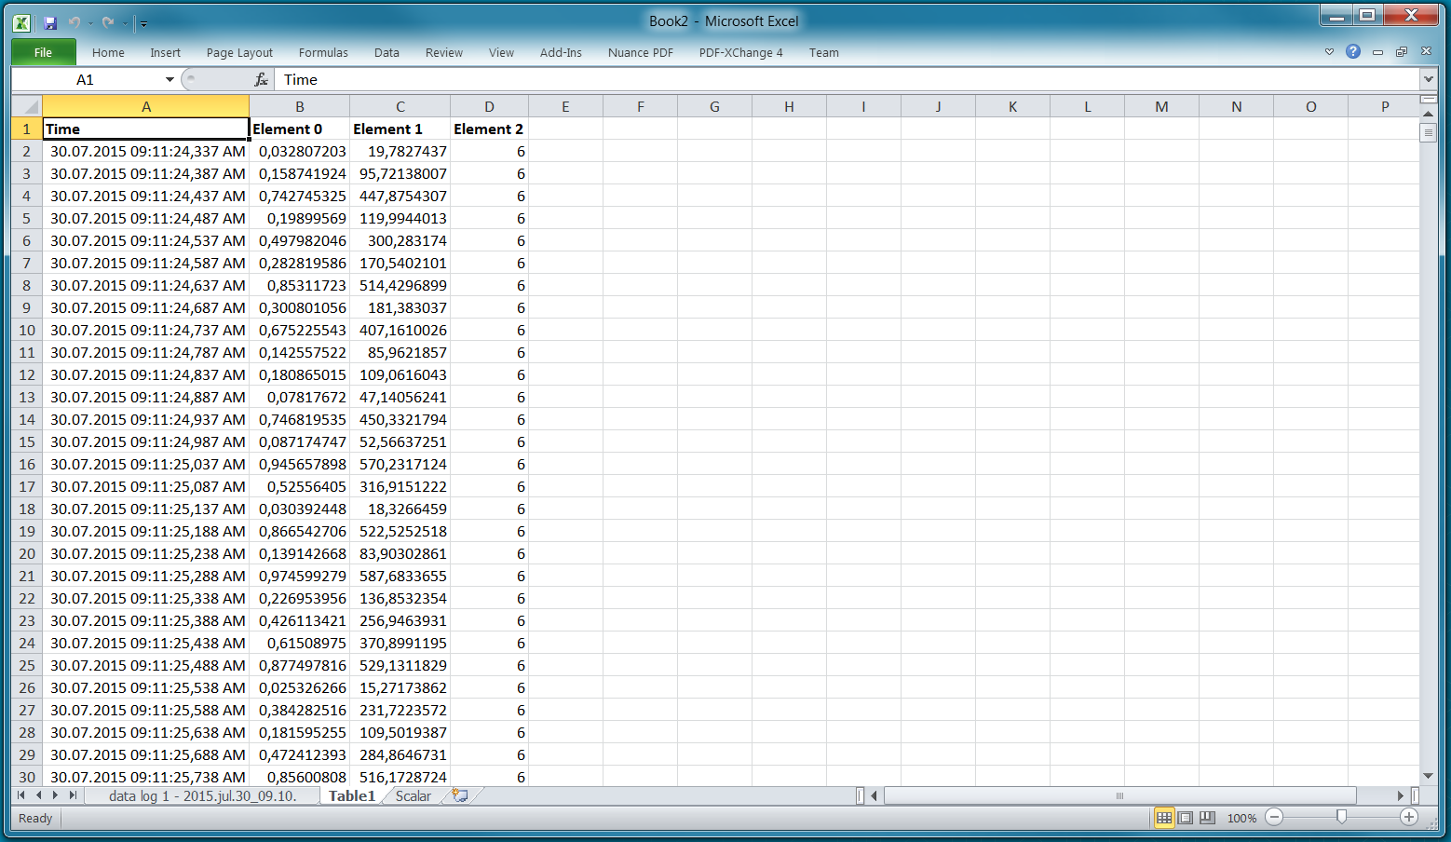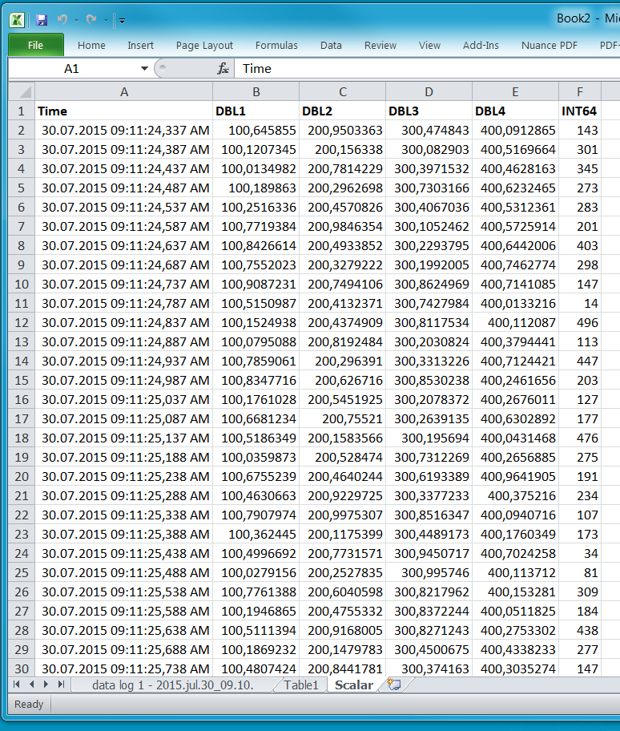 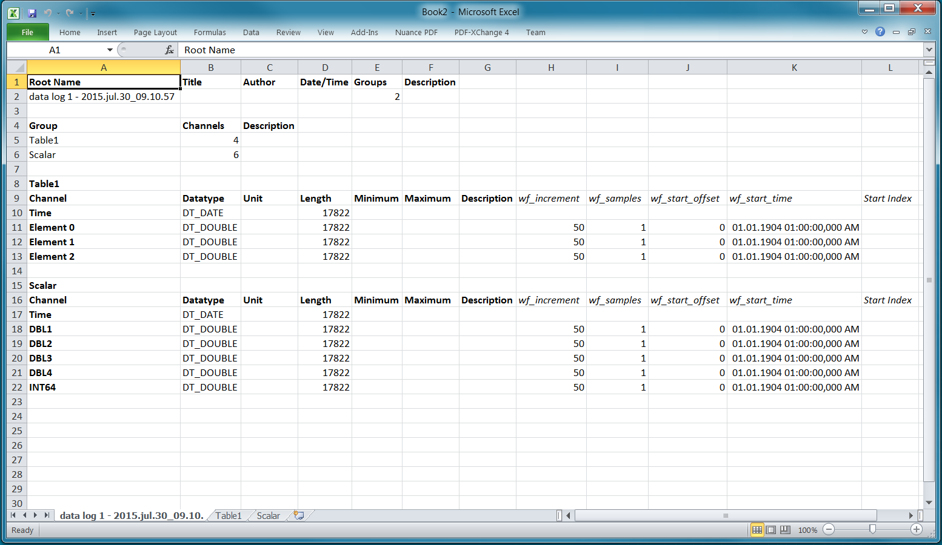

# Revision History

| **Rev.** | **Reason for issue** | **Date** | **Prepared by | Approved by** |
| --- | --- | --- | --- |
| 01 | First issue | July 30, 2015 | EP | EP |

1. Technical Data Management Streaming file format
2. The more custom properties you use to document your measurement data, the more easily it can be located at a later date by using an NI DataFinder client that abstracts complex database communication from the user.